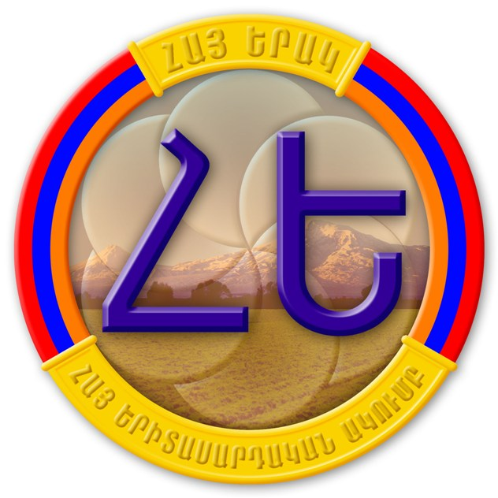

§Ð³Û ºñ³Ï ºñÇï³ë³ñ¹³Ï³Ý ²ÏáõÙµ¦ “Hye Yerak Youth Club”
Ð³ë³ñ³Ï³Ï³Ý Î³½Ù³Ï»ñåáõÃÛáõÝ Non-Governmental Organization

¿É-÷áëï` hye.yerak@gmail.com Ñ»é` 72-31-75, 72-73-32, 091 43-93-21

AGENDA
“National Security Concept of RA: Comments and Analysis”
Conference–discussion

15:00 Registration of participants

15:30 Opening Remarks
Stepan Khzrtian, Coordinator-General, “Hye Yerak Youth Club” NGO

15:35 Vigen Sargsian, Assistant to RA President

16:00 Armen Ayvazyan, Political Sciences, PhD, Director of “Ararat”Center for Strategic Research

16:25 - 17:20 Question and Answer; Discussion
Richard Giragosian, political analyst
Vahram Petrosian, YSU professor
Stepan Khzrtian, “Hye Yerak” NGO

17:20 Closing Remarks
Amalya Hovsepyan, project director, “Hye Yerak Youth Club” NGO

